**Analysis based on Summary Charts**

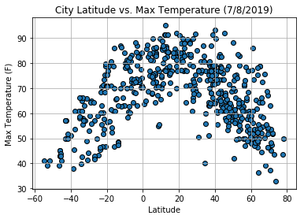

**Latitude vs. Temperature Plot**

* The temperature seems to rise as we move closer to the equator
* The temperature drops as we move away from the equator and towards the north and south poles.
* City of Mamallapuram, India was the hottest city with a temperature of 95 F on 7/8/2019
* City of Dikson, Russia was the coldest city with a temperature of 32 F on 7/8/2019

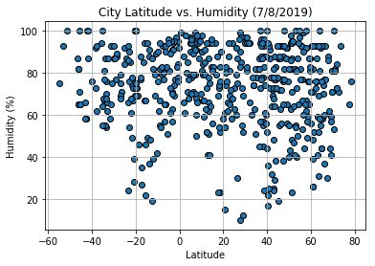

**Latitude vs. Humidity Plot**

* Most of the cities seem to have Humidity more than 60%.
* Some of the cities with latitude close to -20 have have humidity less than 40%.
* City of Adrar, Algeria had the lowest humidity of 10%

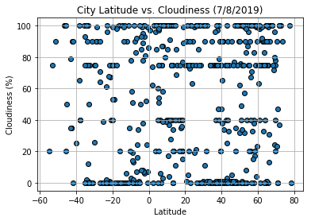

**Latitude vs. Cloudiness**

* The clodiness seems to be distributed evenly across the latitudes and there is no prominent trend or corelation between the latitude and cloudiness.
* There are few trend lines with perfectly alligned plots that are visible and maybe connected to other weather factors.

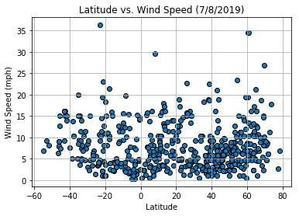

**Latitude vs. Wind Speed**

* Most of the cities seem to have wind speed less than 15 mph.
* The city of Rikitea, French Polynesia had the maximum wind speed of 36.28 mph on 7/8/2019.